# Gambler Plus

## Definition

**# Source**: **Chatgpt (GPT-5-Standard) at [8/27/2025]**



**Gambler Plus** is a YouTube channel that focuses strictly on video game-related content. It covers genres such as gameplay, storytelling reviews, anime, and movie adaptations of video games—offering entertainment and commentary within the digital media sphere. It does **not** delve into real-money gambling or casino content.

## Key Highlights

**# Source**: **Chatgpt (GPT-5-Standard) at [8/27/2025]**

* **Dedicated to Gaming Entertainment**: All content centers around video games, including narrative reviews, anime-inspired topics, and cinematic gaming experiences.
* **Cross-Media Celebration**: The channel bridges multiple entertainment formats—video games, anime, and movies—catering to fans of immersive digital storytelling.
* **Engaging and Inclusive**: Its tone is casual and inviting, making it accessible to a broad audience interested in gaming culture and multimedia narratives.

## Summary Table

**# Source**: **Chatgpt (GPT-5-Standard) at [8/27/2025]**

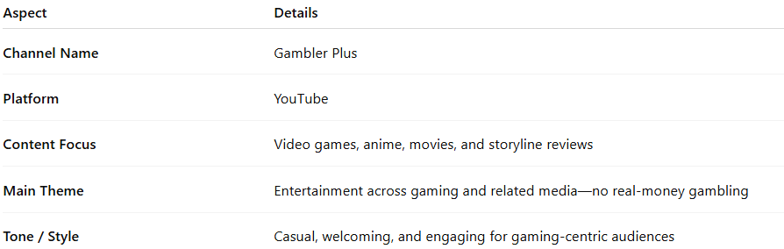

| **Aspect** | **Details** |
| --- | --- |
| **Channel Name** | Gambler Plus |
| **Platform** | YouTube |
| **Content Focus** | Video games, anime, movies, and storyline reviews |
| **Main Theme** | Entertainment across gaming and related media—no real-money gambling |
| **Tone / Style** | Casual, welcoming, and engaging for gaming-centric audiences |